BLUESTOCK
MUTUAL FUND ANALYTICS
CAPSTONE PROJECT
An End-to-End Data Analytics Pipeline for the Mutual Fund Industry
Submitted By
Harsh Gupta
Technologies Used
Python • Pandas • SQLite • SQL • Power BI • GitHub
June 2026
Table of Contents
Abstract 3
Project Objectives 4
Dataset Description 5
Project Architecture 6
Data Cleaning Process 7
Exploratory Data Analysis 8
Performance Analytics 9
Advanced Analytics 10
Power BI Dashboard 11
Key Findings 12
Conclusion 13
Future Enhancements 14

Note: Right-click the table above and select “Update Field” in Microsoft Word to populate the page numbers.

Abstract
This project presents a comprehensive analysis of the mutual fund industry through a complete data analytics pipeline. The workflow spans data ingestion, data cleaning, exploratory data analysis, performance analytics, advanced analytics, and dashboard development.
The primary objective is to transform raw mutual fund data into actionable insights that support a deeper understanding of investment trends, fund performance, and overall market behaviour, ultimately enabling more informed, data-driven decision making for investors and stakeholders.

Project Objectives
The key objectives defined for this capstone project are as follows:
- Build an end-to-end ETL (Extract, Transform, Load) pipeline for mutual fund data.
- Clean and validate the underlying datasets to ensure data quality and consistency.
- Perform Exploratory Data Analysis (EDA) to uncover patterns and trends.
- Calculate key fund performance metrics for risk and return assessment.
- Conduct advanced analytics to derive deeper, actionable insights.
- Build an interactive Power BI dashboard for stakeholder reporting.
- Generate clear business insights to support investor decision-making.

Dataset Description
The analysis is built on ten interconnected datasets covering different aspects of the mutual fund industry, ranging from fund-level reference data to investor transaction records.
No. | Dataset | Description
1 | Fund Master | Core reference details for each mutual fund scheme.
2 | NAV History | Historical Net Asset Value records used to track fund movements over time.
3 | AUM by Fund House | Assets Under Management data segmented by fund house.
4 | Monthly SIP Inflows | Monthly Systematic Investment Plan contribution data.
5 | Category Inflows | Investment inflow data segmented by fund category.
6 | Industry Folio Count | Investor folio counts across the mutual fund industry.
7 | Scheme Performance | Performance records for individual mutual fund schemes.
8 | Investor Transactions | Transaction-level records of investor activity.
9 | Portfolio Holdings | Holdings data describing each fund's underlying portfolio.
10 | Benchmark Indices | Benchmark index data used for performance comparison.
Total Datasets: 10 CSV files
Database: SQLite Database – bluestock_mf.db

Project Architecture
ETL Pipeline
The data pipeline follows a standard Extract, Transform, Load (ETL) approach, supported by a dedicated validation stage to ensure data reliability.
Extract
Raw CSV files are loaded using Pandas.
Transform
- Missing value handling
- Data type conversion
- Duplicate removal
- Validation checks
Load
Processed datasets are loaded into the SQLite database.
Validation
- AMFI code verification
- Missing value checks
- Schema validation
Supporting Screenshots

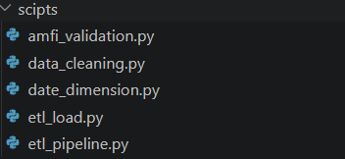

The project follows a modular ETL architecture. Separate scripts were developed for validation, cleaning, loading, and pipeline execution, improving maintainability and scalability.

Data Cleaning Process
Before analysis, all raw datasets were processed through a structured cleaning workflow to ensure accuracy, consistency, and analytical readiness.
Cleaning Activities
- Missing value treatment
- Duplicate record removal
- Date standardization
- Column normalization
- Data consistency checks
Output
Cleaned datasets are stored in the data/processed/ directory, ready for downstream analysis and reporting.

Exploratory Data Analysis
Exploratory Data Analysis (EDA) was carried out to understand the underlying structure of the data and to identify early trends across investors and fund performance.
Analyses Performed
- State-wise investor distribution
- Gender distribution
- AUM growth trend
- SIP trend analysis
- Category inflow analysis
Supporting Visuals

INVESTOR AGE GROUP DISTRIBUTION
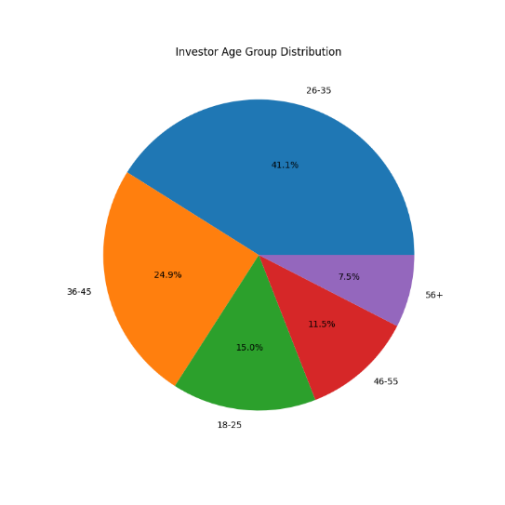
Findings: The majority of investors belong to the working-age population, indicating strong participation from individuals in their earning years. Younger investors are increasingly adopting mutual fund investments

Gender split
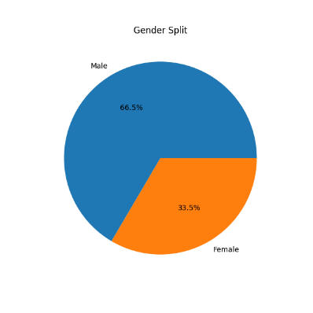
Findings: Male investors constitute a larger share of the investor base, though female participation is also significant, reflecting growing financial awareness.

TOP STATES BY INVESTMENT AMOUNT
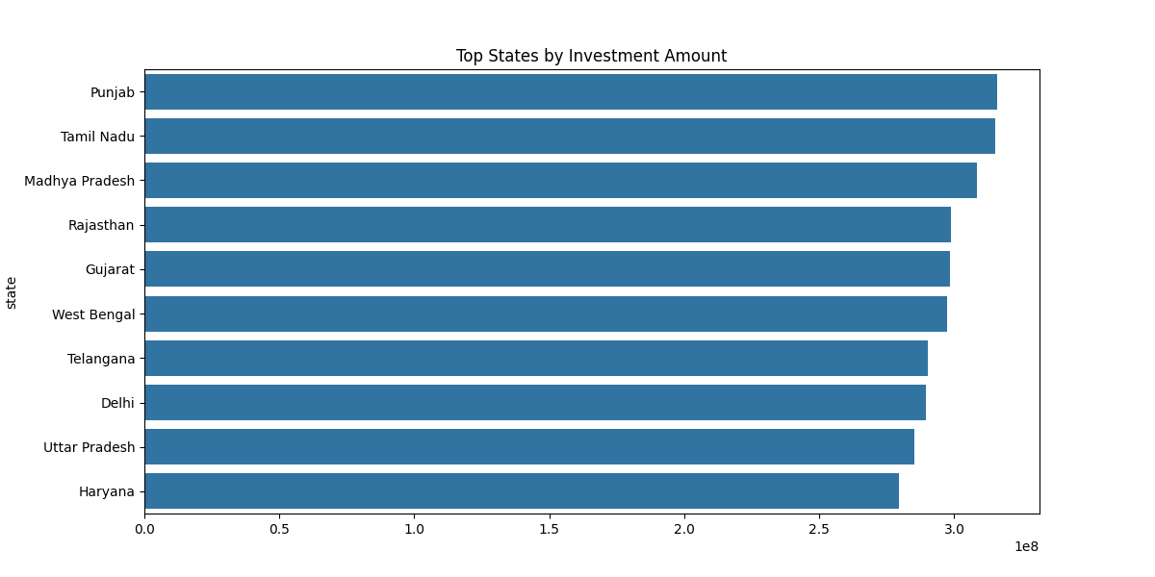
Findings: Investor participation is concentrated in a few major states, highlighting regional differences in mutual fund adoption.

AUM BY FUND HOUSE
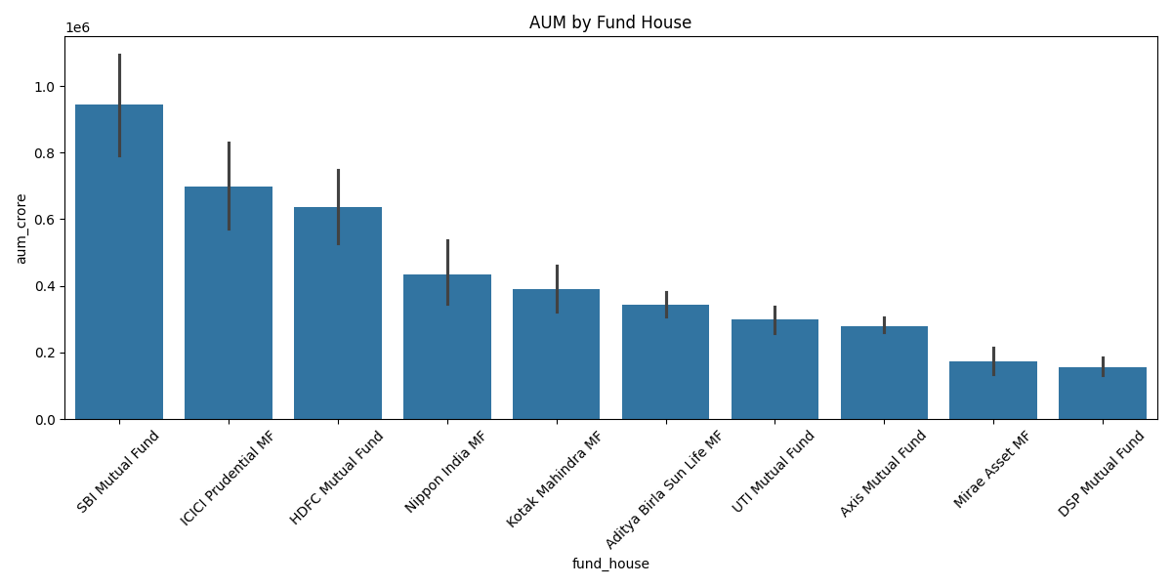
Findings: Assets Under Management have shown a consistent upward trend, indicating increasing investor confidence and growth in the mutual fund industry.

Performance Analytics
A set of standard performance metrics was calculated to evaluate fund returns on a risk-adjusted basis and to compare fund performance against relevant benchmarks.
Metrics Calculated
Metric | Description
CAGR | Compound Annual Growth Rate – the annualized rate of return over a period.
Alpha | Excess return of a fund relative to its benchmark.
Beta | Sensitivity of a fund's returns to overall market movements.
Volatility | Degree of variation in a fund's returns over time.
Sharpe Ratio | Risk-adjusted return measure comparing excess return to volatility.
Maximum Drawdown | Largest observed decline from a peak to a trough in fund value.
Purpose
These metrics evaluate risk-adjusted fund performance and enable meaningful comparison against benchmark indices.
Supporting Outputs

ALPHA VS BETA ANALYSIS
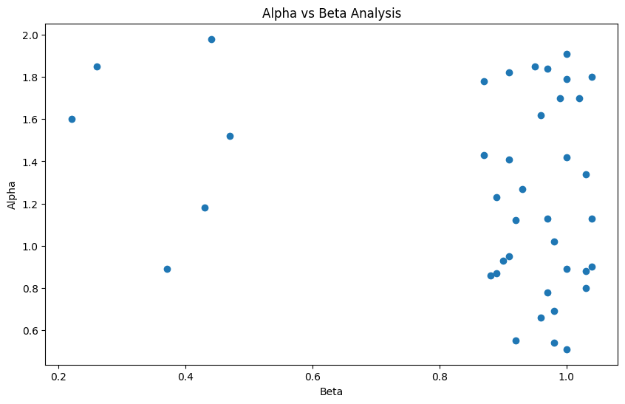

BENCHMARK INDEX TRENDS
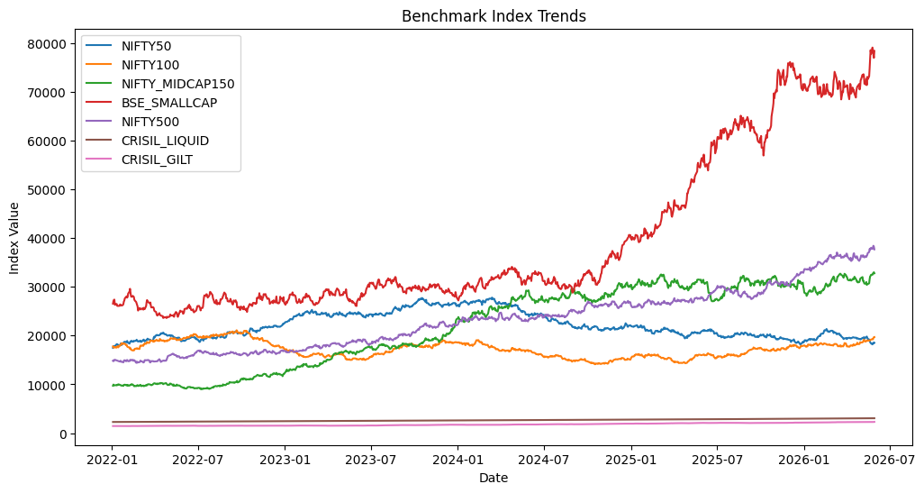

Performance metrics such as CAGR, Alpha, Beta, Sharpe Ratio, Volatility, and Maximum Drawdown were calculated to evaluate fund returns and risk-adjusted performance. Benchmark comparisons provide additional context for fund evaluation.

Advanced Analytics
Beyond standard performance metrics, additional advanced analyses were performed to uncover relationships between funds and identify top opportunities for investors.
Correlation Analysis
Examines the relationship among mutual fund NAVs to identify funds that move together or independently of one another.
Fund Ranking
Identifies the top-performing mutual funds based on calculated performance metrics.
Sector Allocation Analysis
Analyzes sector-wise investment concentration to highlight where fund portfolios are most heavily weighted.
Supporting Visuals

NAV RETURN CORRELATION MATRIX
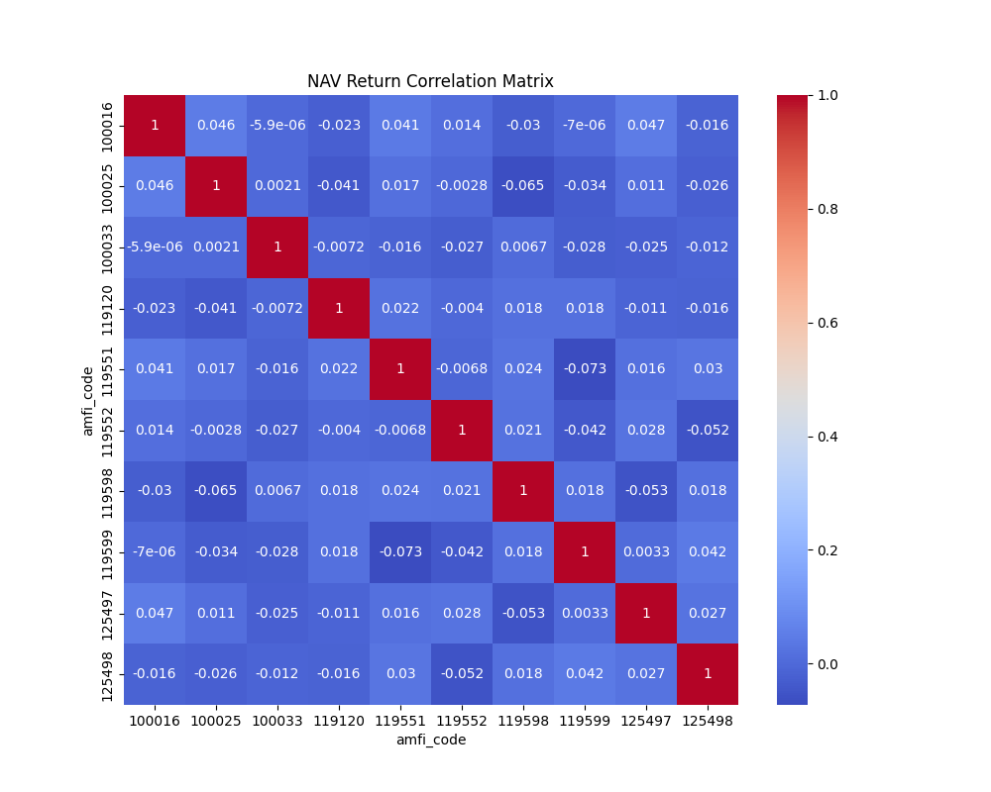

SECTOR ALLOCATION ACROSS FUNDS
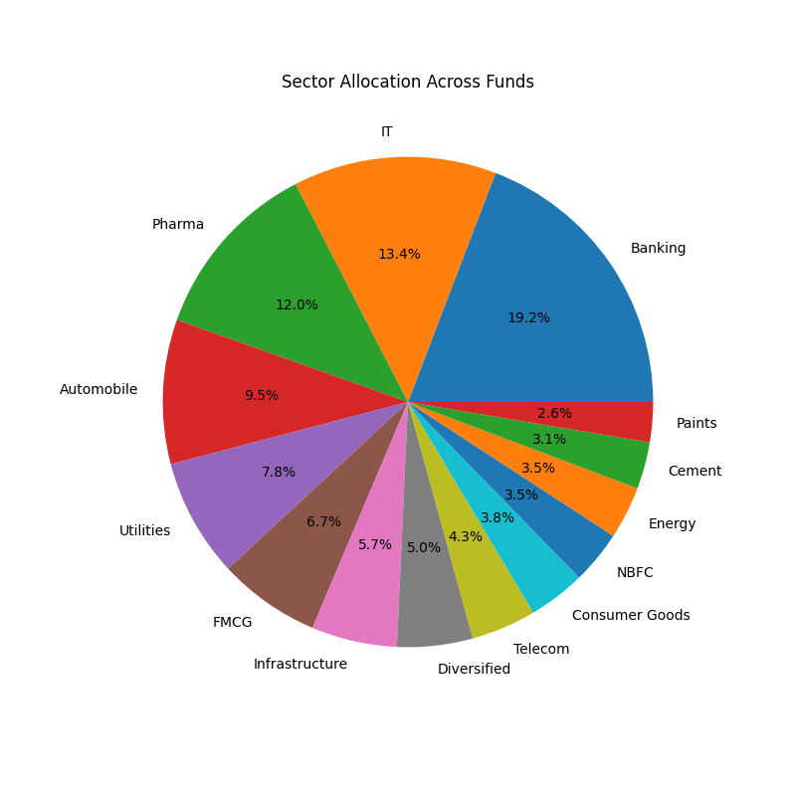

TOP 5 FUNDS SCORECARD
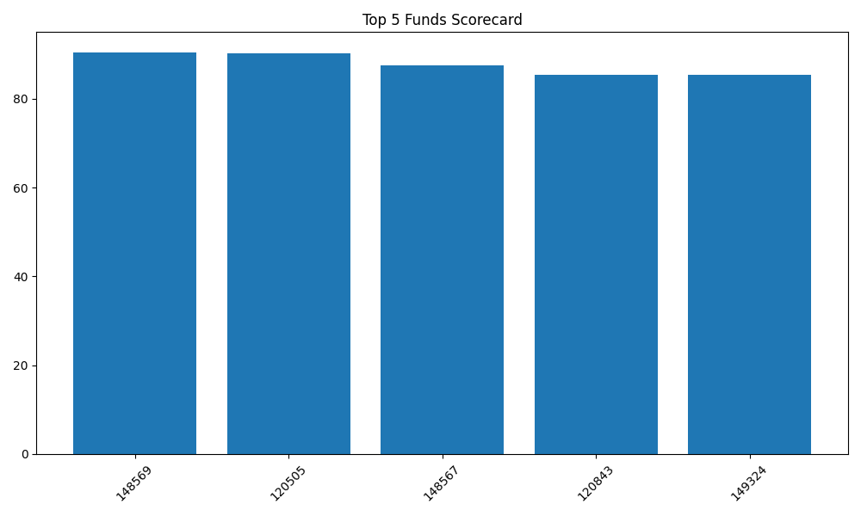

Power BI Dashboard
An interactive Power BI dashboard was built to present the analysis in a stakeholder-friendly format, organized across five dedicated pages.
Page | Dashboard Section
1 | Industry Overview
2 | Fund Performance
3 | Investor & SIP Analysis
4 | Market Trends
5 | Executive Summary

Supporting Screenshots

PAGE1
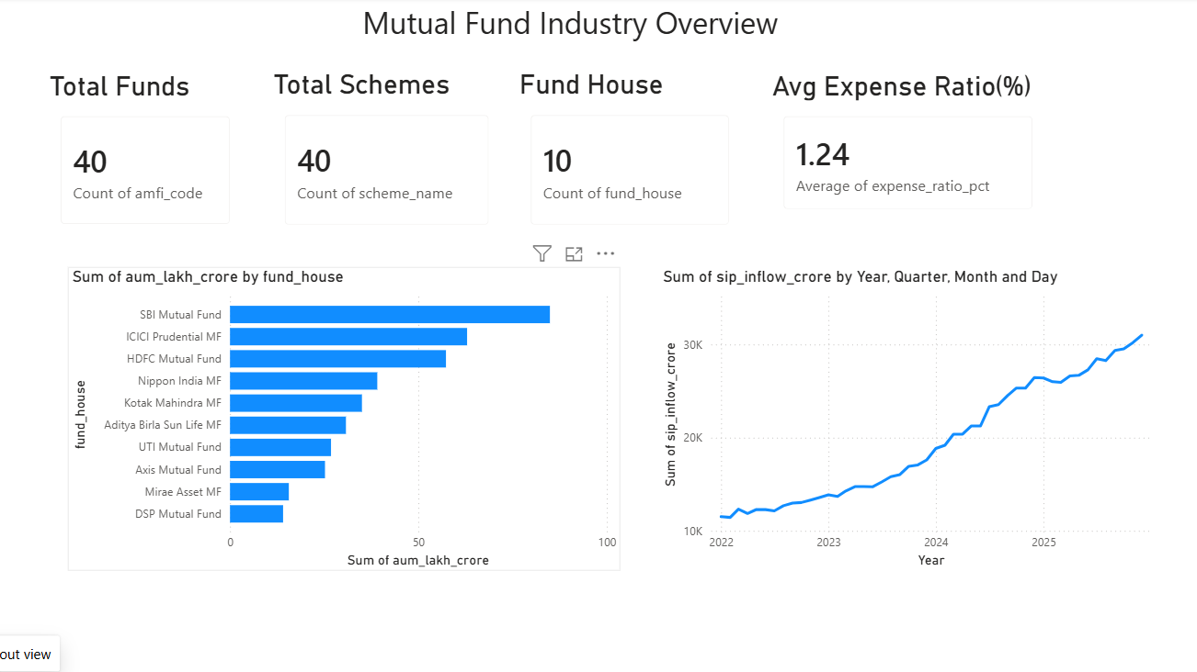

PAGE 2
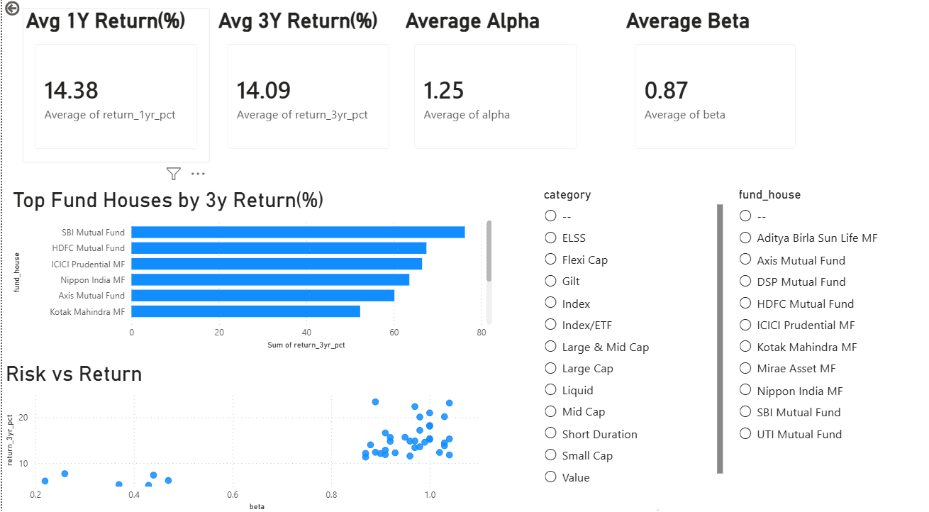

PAGE3
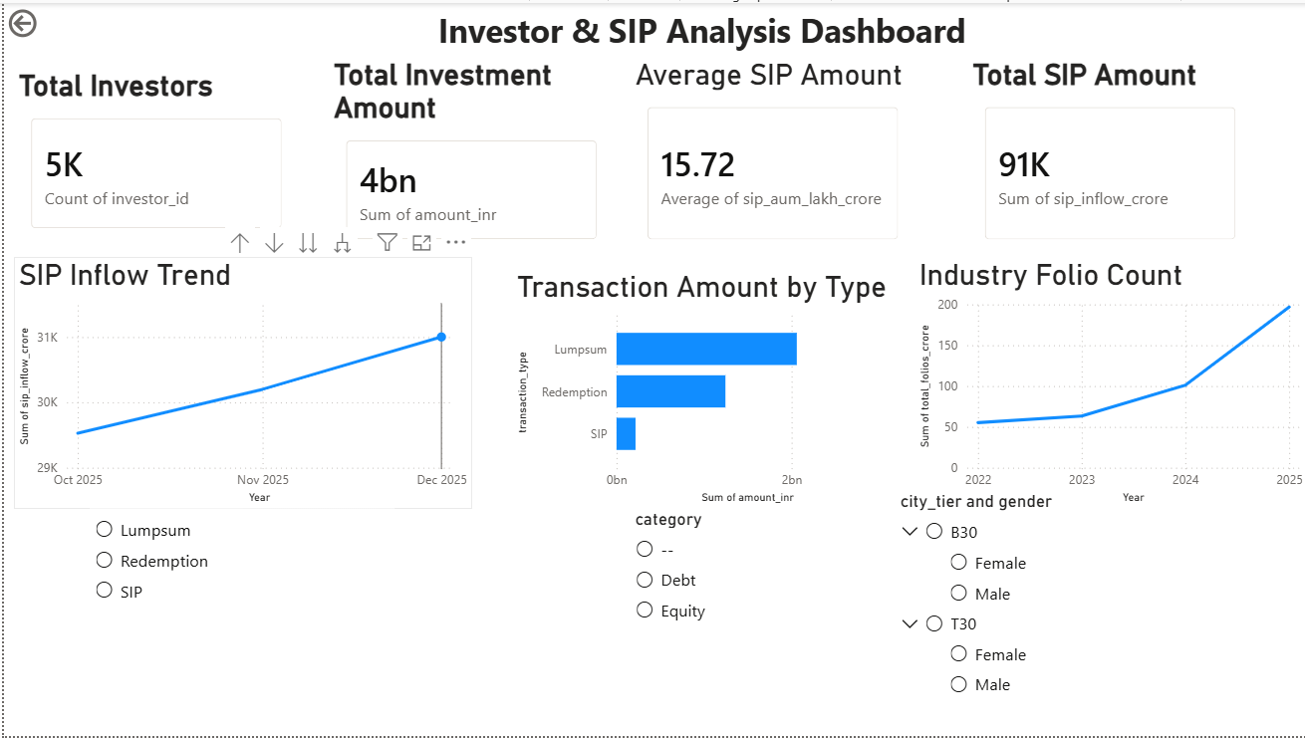

PAGE4
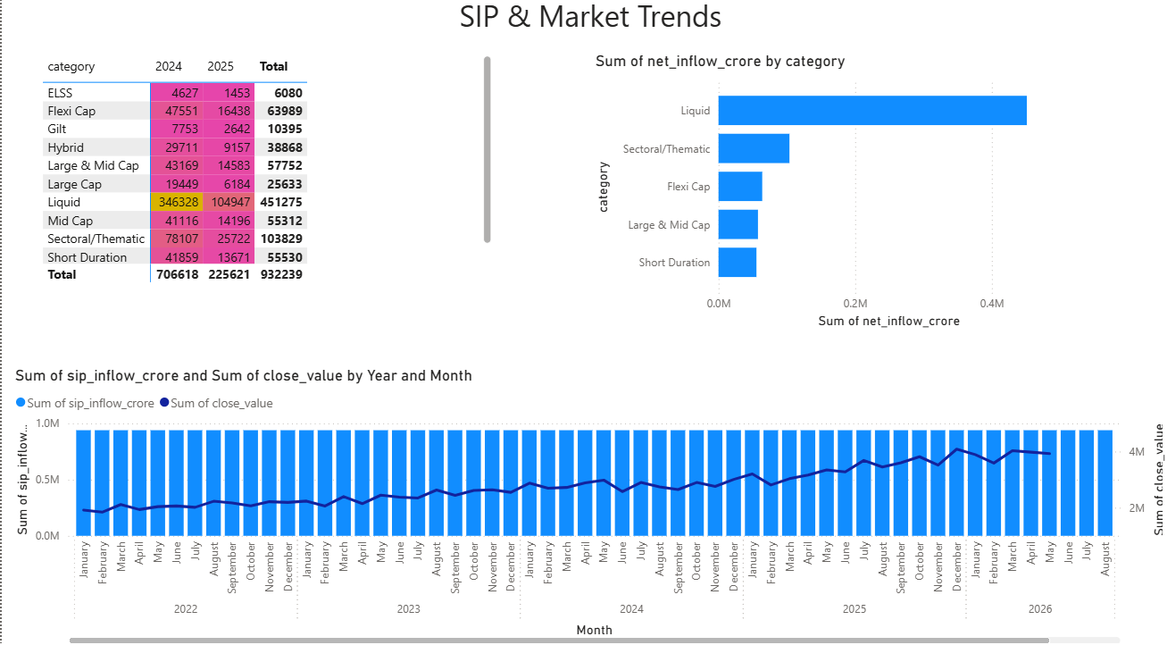

PAGE 5
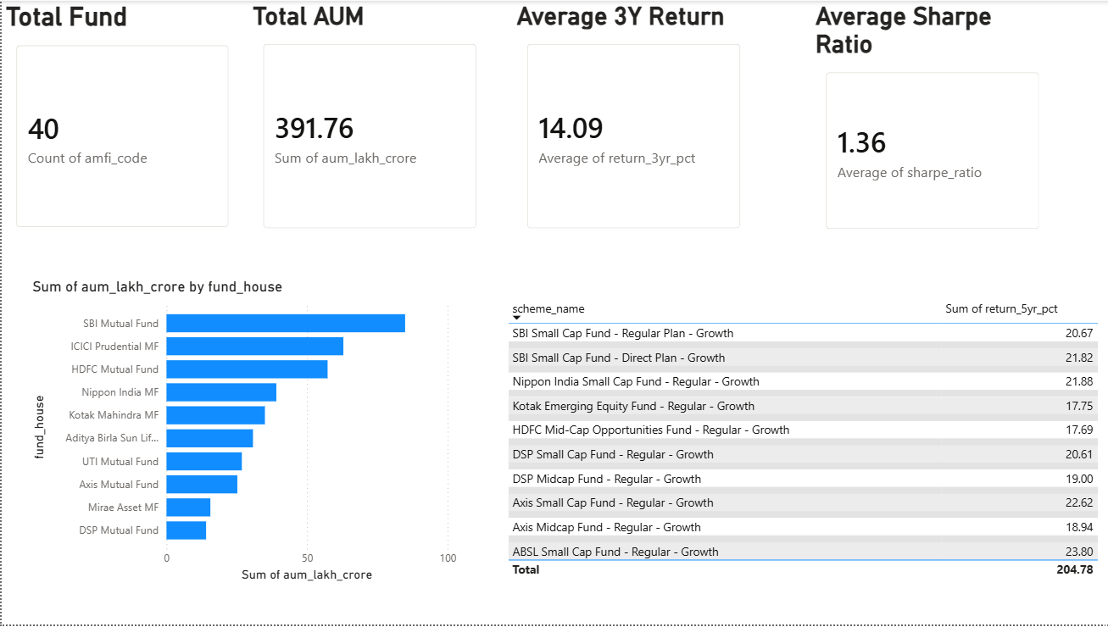
The Power BI dashboard provides an interactive view of mutual fund industry trends, investor behavior, performance metrics, and market insights, enabling effective business decision-making.

Key Findings
- Mutual fund AUM has shown continuous growth over the analysis period.
- SIP inflows indicate increasing retail participation in mutual funds.
- Equity funds dominate investor preference compared to other categories.
- Top-performing funds consistently outperform their benchmark returns.
- Sector allocation shows a concentration of investments in a few major industries.
- Correlation analysis identifies funds with similar performance behaviour.
- Fund rankings help identify consistently high-performing schemes.
- Benchmark indices have a notable influence on overall fund performance.

Conclusion
The Bluestock Mutual Fund Analytics Capstone Project successfully implemented an end-to-end analytics pipeline using Python, SQLite, SQL, and Power BI. Raw mutual fund datasets were transformed into meaningful business insights through a combination of data engineering, analysis, and visualization techniques.
The resulting dashboard provides a comprehensive view of industry trends, fund performance, investor behaviour, and market movements – enabling data-driven decision making for investors and stakeholders alike.

Future Enhancements
The following enhancements have been identified as potential next steps to extend the value and capability of this project:
- Real-time NAV updates
- Automated ETL scheduling
- Predictive fund return modeling
- Machine Learning integration
- Cloud deployment
- Interactive web dashboard

